Car Sales and Registrations going down in Ghana
Author: Emmanuel Darku
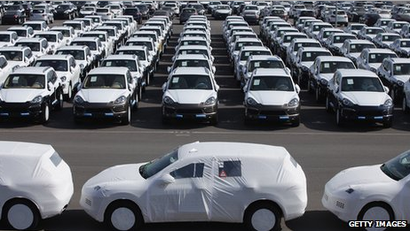
The Ghanaian momentum sagging economy is affecting the automobile sector. Car dealers are seeing fewer footsteps in their showrooms and this depression situation is not to change till end of this year. The automobile sector is crying for changes and help from the government but they hear no answer. The focus of the Ghanaian government is to solve its fiscal and electricity crises.
Are the glorious years of Ghana automobile sector over?
According to the figures from Bank of Ghana (BOG) and Driver and Vehicle Licensing Authority (DVLA), vehicle registrations went down from 191,000 units in 2013 to 131,000 units in 2014. This shows a downfall of about 31% in 2014.
The slowdown continued in the first quarter of this year according to BOG and DVLA. Vehicle registrations decreased about 25% to a level of 41,000 units compared with 56,000 units in the same period in 2014. Interest rate is on a high level of 25% since the last 10 years and doesn’t give a room for lenders. A 38.3% lending rate is taken when borrowing money from a bank. This financial stage doesn’t help the automobile sector to develop as it should. But despite the decline in the automobile sector and the sagging economy, the middle-upper class income in Ghana rising each year and hunger of buying cars is also rising. These two factors with a help from BOG by decreasing interest rates and a growing economy will help the automobile sector to recover. The recovery is expected around 2017.

