CAUCUS FOR DEMOCRATIC GOVERNANCE-GHANA

NiiSaiAbabio Road, 20ARS Roundabout, EastLegon Accra, Ghana, Tel +233-501665366

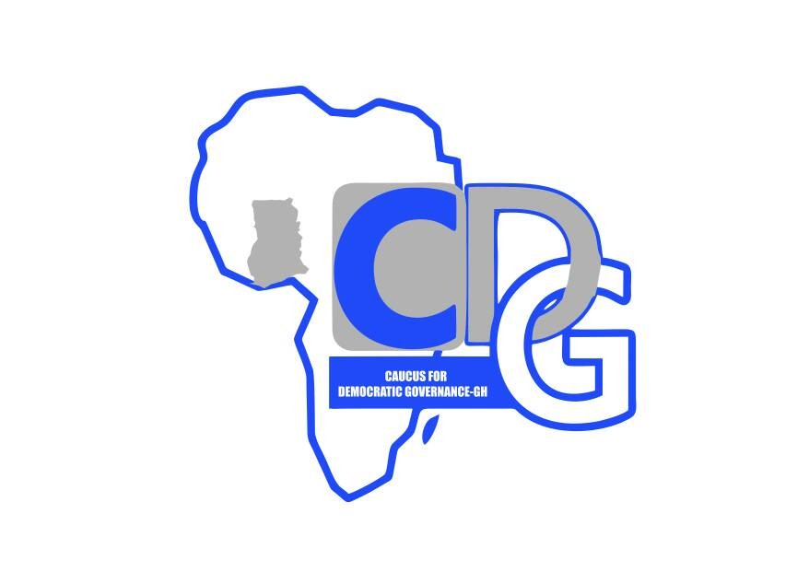

EDITOR

PRESS RELEASE 20TH JULY 2021

PROTECTING THE PUBLIC PURSE – PART II
Ghana is Bleeding

Preface
Caucus for Democratic Governance (CDG-GH) is worried that the economy is still bleeding and struggling for survival, since the last four years ; looking at the abysmal economic performance and the Auditor General`s (AG`s) report for the past four years. The AG`s 2020 report, submitted to Parliament last week, presupposes a deliberate attempt by family and friends Government to deplete the public purse; showing zero tolerance and abject disregard for the suffering masses.

AG`s Report
The audited Government`s accounts for the period 31/12/2019 - 31 /12/ 2020 reveal shocking budget overrun of GHC 8.8 billion ; above the approved GHC 54 billion (1.4 billion US$). In what appears to be the scramble for national exploit, the office of the Government Machinery, that is, the direct office of the President, spent an excess of GHC 54 million in addition to GHC 4.1 billion approved by Parliament for that office.
Jean Mensa`s Electoral Commission exceeded her budget limits by a whopping GHC 159 million. This is after spending GHC 1.5 billion as her allocation.
The Energy Ministry spent in excess of their approved budget, a colossal sum of GHC 4 billion. That was in addition to the GHC 6 billion approved by Parliament.
The Ministry for the Interior was not left out of the uncontrolled spending and grabbing of booty. They overspent by GHC 2 billion, after exhausting their approved allocation of GHC 6 billion.
These budget overrun, according to the Auditor General Johnson Akuamoah Asiedu, blatantly offend the Appropriation Act 2019 (Act 1008) and section 29 of the PFM Act. At this rate of indiscriminate consumption, one is left wondering, if Nana Addo was lying when he promised to protect the public purse.

Public Debt
The alarming rate at which the public debt is increasing is scary. Ghana`s total debt add up to 320 billion ; 78% of our GDP. In spite of the precarious condition of the crippled economy, the President is lavishly spending the taxpayer`s money on himself, his wife and friends. After increasing his salary by 130%, he decides to pin down the civil service with a meager increase in salary of 4%.

Misuse of Funds
At a time when Nana Addo was on his knees begging for debt cancellation, from the Western world he decided to :

- charter a luxurious class aircraft costing 15,000 pounds an hour for 23 hours. A trip to France which would have cost 420,000 GHC, ended up costing the taxpayer GHC 2.8 million, much to the surprise of Ghanaians. A senseless waste of money.

- when we were recovering from this senseless spending, we were hit by judgment debts for abrogating the contracts between Ghana Power Generation Company and Ghana government and West African Gas Limited and the Ghana government. As a result, Ghana has lost a total of GHC 1,8 billion.

- on the instruction of the President, excavators and mining equipment seized from miners were burnt. As a result, Ghana is paying over GHC 25 million to various small scale and galamsey operators.

- Covid-19 vaccines were bought from dubious middlemen, at $19 instead of $10. Besides packs of tissue papers were also bought at 175 GHC per pack, As a result, Ghana has lost about US$ 10 million through reckless profit making venture.

- Nana Addo`s misguided and misplaced priority, led him, in these difficult times, to pay his spouse and the spouse of Dr Bawumia salaries totaling about GHC12 million GHC.

Conclusion
The causal relations between, the call on Nana Addo to fix the country and the desperate suffering Ghanaians cannot be disputed. Last week the youth of the opposition party were on the street drawing the attention of Nana Addo to the suffering of the people and poor governance. Situations that are close to explosive levels. Citizens have no jobs, and so cannot afford accommodation, cannot afford three square meals a day. Food prices, transportation and taxes are high, and yet monies coming into the public purse through taxes and through borrowing are quickly spent lavishly. Nana Addo must resign for incompetence and lack of leadership traits.

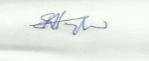
Dr E. K. HAYFORD
EXECUTIVE DIRECTOR CDG-GH
0277606338 / 0243609277

.

Chief convener: Dr. E.K Hayford( 0501646136/0277606338) Conveners: Justice Kpornyo(0243854582) Sylvester KafuiMintah(0240717024) Edward Mortey(054976477) JoycelinAkorli (0243623308)

