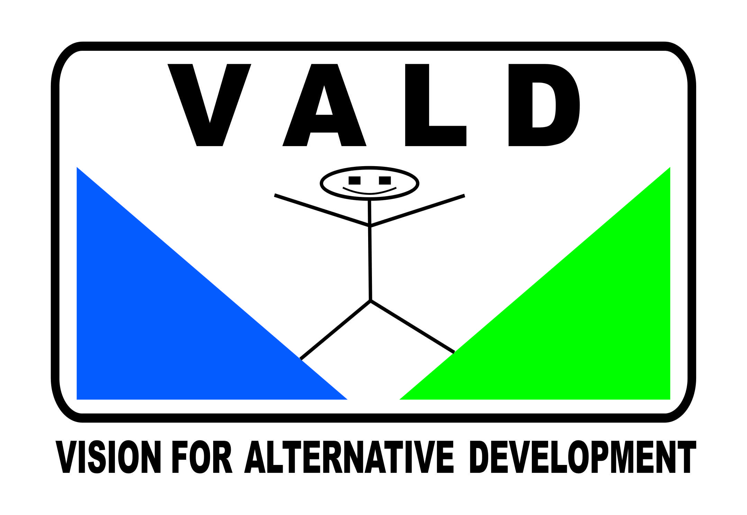
PRESS RELEASE
14th July, 2021
Sarkodie; A Celebrity in Tobacco Use –A bad example for the Youth
The Vision for Alternative Development (VALD), the Ghana Non-Communicable Diseases Alliance (Ghana NCD Alliance), Media Alliance in Tobacco Control and Health (MATCOH), Jaishi Initiative, and the Community Health Support Team (CHEST) wish to express disappointment and condemnation of the display of public smoking carried out on social media by Mr. Michael Owusu Addo, known in ShowBiz circles as Sarkodie.

We are very disappointed in Sarkodie for circulating pictures of himself smoking a cigar on social media without considering the negative influence this singular act stands to have on the public especially the youth most of who consider him as their role model. The whole world is currently at a stage where countries including Ghana are finding effective and lasting solutions to curb the rate at which tobacco products are exposed and used by minors, and to safeguard the health of both smokers and non-smokers. We find the act by the two-time BET Award winner as unprofessional, unethical and unhealthy. The youth by virtue of their youthful exuberance and experimentations follow the paths of individuals they have idolized and such must not be led into deadly pits by these same idols, rather they must impact good morals in them.

Tobacco use is one of the leading preventable causes of deaths in the world with most deaths occurring in low-and-middle-income countries (LMICs) including Ghana. It is estimated that annually about 8million lives are lost to tobacco use, while 600,000 people are also killed by exposure to tobacco smoke worldwide. Tobacco is lethal and deadly and has no single benefit except to kill, maim and destroy. The use of tobacco products causes chronic non communicable diseases (NCDs) such as heart disease, stroke, lung diseases, diabetes, and chronic obstructive pulmonary disease (COPD), which include emphysema and chronic bronchitis. Smoking also increases the risk for tuberculosis, certain eye diseases, and problems of the immune system, including rheumatoid arthritis and many more. Cost of treatment for these effects are very high which sends majority to their early graves and leads families into abject poverty. It is important to note that smokers have a high risk of contracting COVID-19 due to weak immune system as a result of smoking.

We call on rapper Sarkodie to desist from this act of publicly showcasing his smoking skills and the brands in both his pictures and music videos to avoid indirectly ushering innocent youth into the act of thinking smoking is of benefit because their ‘idol’ smokes. We expect Sarkodie to use his influence and his platforms positively to educate and instill good morals including healthy living in his followers and the general public.

Smoking any form of tobacco product is injurious to health, therefore, normalizing its use by well-respected and hailed celebrities will encourage young people to take up the habit and consume more at the peril of their lives. We are troubled that these images glamorize smoking and serve as celebrity endorsements that could encourage young fans to initiate the smoking habit and possibly graduate to smoking other hard drugs.
Already Ghana is faced with increase rate of shisha smoking among the youth in second cycle institutions and the universities - meanwhile, studies clearly show the huge negative impact of smoking which has caused some countries to ban its use completely.

Will rapper Sarkodie be happy to see the youth take up the habit of smoking, knowing that apart from the cancerous nature of the product which is expensive to cure, it also cuts short the life span of smokers by half?

Just few weeks ago, during this year's World No Tobacco Day commemoration, the World Health Organization (WHO) began a campaign “Commit to Quit” and so we find this act as a threat to all these efforts by well-meaning people.

We are by this statement calling on the singer to render an apology to all Ghanaians especially the youth for such a distasteful act that has the propensity of changing behaviors of our youth from good to bad and pledge to support and promote the health and well-being of all.

Finally, we wish to also inform all Ghanaians, especially those in the entertainment industry to note that Ghana’s Public Health Act (Act 851) under part 6 which talks about tobacco control measures prohibits tobacco advertising, promotion and sponsorship of tobacco and tobacco products and the Tobacco Control Regulations also bans tobacco and tobacco products in the entertainment media.

For more information Contact
Labram Musah
Director of Programs-Vision for Alternative Development
National Coordinator, Ghana NCD Alliance
+233-243-211854 labrammmusah@valdghana.org

