CAUCUS FOR DEMOCRATIC GOVERNANCE-GHANA

NiiSaiAbabio Road, 20ARS Roundabout, EastLegon Accra, Ghana, Tel +233-501665366

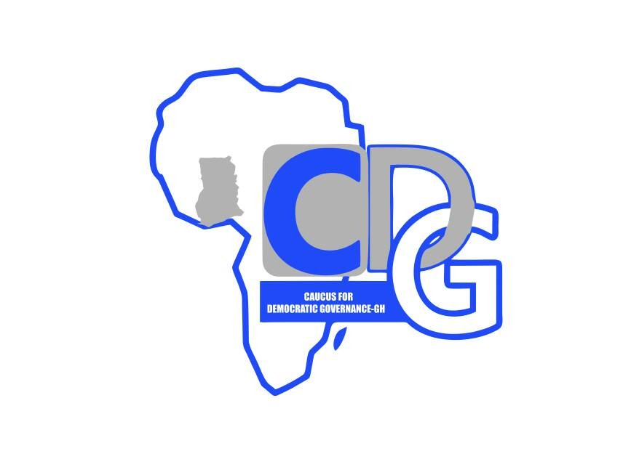

EDITOR
PRESS RELEASE 5^{5th} JULY 2021

BAD SECURITY STRUCTURES IN LEADERSHIP
Is our problem
Preface
Caucus for Democratic Governance (CDG-GH) is of the view, that leadership in democracy is all about upright character, honesty, accountability, and social justice. Setting good example as servant leader, alleviating the social suffering of the people, building a nation that citizens can be proud of, within the ramifications of the Constitution, is all that is required. The suppression of democratic rights and promotion of corruption cannot and should not be part of governance. The use of brut force by police and military to suppress citizens into culture of silence, is undemocratic. A Clan leader who holds strongly to self centered beliefs, in defiance to accepted reason and norm, is not a democratic leader.

Ejura Episode
Last week, a social media activist-and an advocate of “fix the country”, Ibrahim Mohammed aka Kaaka, was brutally murdered by a mob close to his house in Ejura (Ashanti Region). Two days later the military clashed with protesting Ejura Sekyedumase youth, shot at close range killing two and injuring four. In connection to this story, former chief of Defense Staff, Brigadier Joseph Nunoo Mensah, in an interview said, that soldiers “are paid to shoot and kill”, and so cannot be sent to face unarmed crowd of citizens. Besides, “A soldier`s job is not to disperse crowd”.

Shoot to Kill
In spite of this norm, soldiers and police under Nana Addo`s government are used to brutalizing citizens, and where possible to shoot to kill. This tactics appears to function as the core strategy of the security structure of this government. Indeed, Nana Addo claims to be a democrat with assertion as civil rights lawyer. Unfortunately, the reality on the ground does not support his apparent assertion; looking at the needless political tensions and violence that have sadly become part of our everyday norm.

Genesis of tension
The Genesis of our present tension started in November 2016, when military personnel from South Africa came to train Nana Addo`s private militia in Ghana. Late 2017, this private militia moved its training camp secretly to Osu Castel. The journalist who investigated and made it public, had to flee for his dear life. As a result of public outcry, this illegal militia moved close to Asutware. Reports reveal, that many members of this private militia have found their way into the Army, Police, Security and Boarder Guard. The rest are in secret training camps, waiting for postings.

Activities of Militia
The result of the activities of the militia, is the violence at Ayawaso West Wougon bye-election, where innocent voters were beaten up, shot and wounded. This episode was followed by many other violent killings at different times. .The naked truth is that not one member of the terror groups perpetrating atrocities has been apprehended or convicted.

In August, last year a “whole” Minister who shot at a harmless crowd at a registration centre in Kasoa, is walking round a free woman. The shooting at Odododiodioo, the shooting and killing of a teacher at Brekum, the shooting at a political convoy at Bolga are all needless violence in an otherwise peaceful Ghana.

In Wa last week, the military for reasons known to themselves brutalized the youth, and it took the Army leadership to diffuse the problem. In Juapong and Techieman, soldiers shot and killed citizen. In Ablekuma, Asawase and Savelugu, the security shot and killed citizens. During the 2020 election (for the first time) eight people were shot and killed by armed police and army in an election. WHY? Certainly Nana Addo has achieved his” ALL DIE BE DIE” mantra.

Illegal Arms
Often, illegal arms imported into the country, disappear into thin air, and those that are sent to the depots, disappear in the depots. We want to know :
- Where is the arms intercepted at the Tema port and handed over to Madam Tiwaa Dankwa in 2018 ?
- Where is the arms intercepted at the Tema port and later sent to GRA depot in 2019?

Conclusion
Inordinate ambition and the insatiable desire to rule, has always ended in failure and destruction; and this is what is happening in Ghana now. Nation building is a democratic exercise that neither require militia nor arm-twisting strategies. Where leaders rule with conscience, honesty and truthfulness in character, there is always harmony. Let us listen to the cry of the people and free them from hunger and servitude.

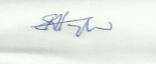
Dr E.K.Hayfod
Executive Director, CDG-Gh
0277606338 / 0243609277

Chief convener: Dr. E.K Hayford( 0501646136/0277606338) Conveners: Justice Kpornyo(0243854582) Sylvester KafuiMintah(0240717024) Edward Mortey(054976477) JoycelinAkorli (0243623308)

